Imagine Cup 2013 – Games category

Trust Team present: Overload

**Game Play Instructions**

**I/ Requirements & installation**

1. Requirements

Our playable demo needs specific pre-requirements.

* A Computer
* An Xbox Gamepad
* Play with a resolution of 1366\*766 (badly, it’s a must for this demo, with our excuse).  
  You not need Internet or other features. Standard Graphics and sounds cards are sufficient.

1. Installation

* Unzip the archive Overload.zip
* Run the installation of XNA frameworks by double clicking on ***xnafx40\_redist.msi***.
* Be sure to have an Xbox gamepad connected to your computer, and to have a screen resolution of 1366\*768.
* Run the installation of the game by double clicking on ***Setup.exe***
* If the game is not started, go on start menu -> programs -> WindowsGame1 and launch it

**II/ How to play**

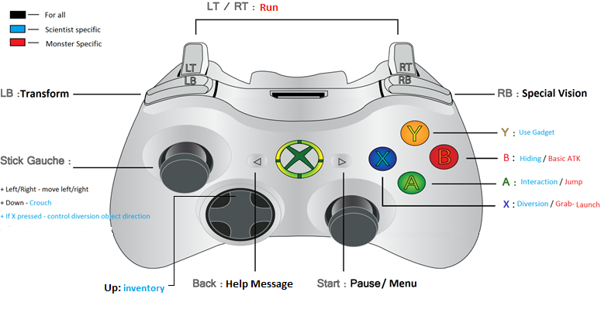There is a picture of the different action possible.

For a better experience, let’s try it yourself ;)

**III/ Specificities of our Game**

Our Level had no notice to explain how the level works. It’s not a Tutorial level, and we placed it approximately at the middle of our game timeline. That’s why, in this part, we want to explain some specifies of our level. But we have, in games, help messages, if you need it. Press the button BACK to move to the next.

Skills

First, if you pressed start button, you have access to a menu, in which you can click on “competences”. It means skills. In this menu, you can activate some of yours skills. We proposed just a few examples of possible skills, in order to simplify our demo. You unlock:

Scientist:

* Climb : permit to climb in climbable object (use A button)
* Vision : permit to use the scientist special vision (use Left Shoulder button)
* Hiding : permit to hiding yourself behind structure like metal box C:\Users\Benbow\Documents\GitHub\SupMTL2013\WindowsGame1\WindowsGame1\WindowsGame1Content\box_hidding.png (use B button)

Monster

* Jump : permit to jump (use A button)
* Vision : permit to use the scientist special vision (use Left Shoulder button)
* Health : up your health points (passive)

Level overview

Important, Spoil inside!

If you want to discover our level by your own, you can try it first. But if you need more information on it, you can read these lines. This level is not a tutorial, it’s not easy to use first time.

* First part : infiltration

You must access on the base without being detected. Unlock your “hiding skills” and try to pass through the lights. You are not spotted if you are hiding behind box. For hiding yourself, press B buttons near a box, in the scientist mode.

* Open doors  
  Use A button in direction of a door
* Activate elevators  
  If you want to activate the elevators, you have to success a puzzle. For this one, you have to repeat the code that appears on the screen. The codes appear, and when it’s your turn, make the good combination. If you success five times, you activate the elevators.
* Fight or infiltration (use diversion)

If you are on Monster mode, you can fight a enemy. There are guards on the level. To attack one, go near him and press B Buttons. If you prefer infiltration, try to pass through him, using hiding and diversion. Hiding is the same as before, but in this case, avoid the vision of the guards. If you are spotted, they will open fire and kill you. Use diversion also. Press X button to enter in diversion mode. You can define a drop point. Press X again to launch an object. If there is a guard near the drop point, he will be disturbed. For more safety, hide yourself and use diversion, you can do hit when you are hiding.

* Radioactive zone

You have a radioactive zone. If you want to pass through it, you have to use a Mask. It’s an item, that you can found in the level (find it ! ). Use the Up button of the directional pad to see you inventory, if you are in scientist mode. You can select your item by using A button on it. To use it in the game, press the Y button. It will activate the selected item of your inventory. To retire it, use Y button again. You can only pass through the radioactive zone with the scientist; the monster will die very quickly.

* Use the Hoist  
  To use the hoist, destroy the two blocks on the platform. To destroy it, punch it with the monster. If it’s done, you will see the hoist balance himself.
* Launch Object  
  You can see a guards, in the other side. He’s not moving at all. If you are with the monster, you can take the box, those who is in the second platform of the hoist, and launch it on the guards. To do it, press X button near the box. You can access to the final zone.
* Climb on a box.

In some object, the scientist can climb on. On the last section, to access to a ladder, you must climb on a box. To do this, unlock the correspondent skill and press A button near the box. You will climb on it.

* Special Vision

In order to see if an object is usable, by the monster or by the scientist, you can use special vision. To use it, press the Right Shoulder button. If you are on scientist mode, a blue vision appears and the blocks usable by the scientist are revealing by a yellow filter. If you are on monster mode, a red vision appears and the blocks usable by the monster are revealing by a yellow filter.

* Reload and Checkpoint

The games reload if you:

* + Falling with the scientist
  + Are spotted by lights
  + Life equal to 0

When one of these conditions are respected, the game reload. If you have passed a checkpoint zone, your game reload at this point, if not, you restart at the beginning.

* Alignment  
  a bar, at the top left of the screen is present during the entire demo. It does determine your alignment. When you play the monster, its increase in the red zone, and when you play the scientist, its decrease to the blue zone.
* Bonus  
  In this level, you can found a “scientist Bonus” who gave to you an extra amount of scientist’s skill points.
* Ending Level

If you reach the end of the level, Congratulations, a message appears with the amount of skill points that you earned. There is two categories: Monster and Scientist. This amount is calculated in function of your alignment. In this example, 1500 skill point are distributed in two parts.